The Relationship between Masculine/Feminine and Parent/Child Dynamics ©

People watching is a popular pastime for many of us. It is intriguing and you get to judge others. The mystery of what another person is like draws us together while the judgmental human nature that most people display allows us to think we are better than others. Most people don’t know why some people instantly make them angry or why a strong dislike for certain people emerges at first meeting. Most people get along well. Some people are only slightly irritating. But some people are offensive the moment they walk into the room. While from their perspective they may like you or not care a whit about you. They may even hate you the moment they see you – all this happens even before anyone has said a word. The reason is found in personality profiling. It is in distinctly differing personalities that people almost instantly like, hate, or become indifferent toward one another. Few of us, however, truly know how to be fair and accurate in determining how another person runs their life. Uniqueness is fascinating. This article explains how someone can be different from you and not be wrong or worthless.
Towards the end of 1999 Albert Einstein was chosen to be Time magazine’s “Person of the Century”. It was because of him that we now reap the rewards today of his great advances in science and technology. Ongoing generations will continue to learn the mysteries of the nature of the universe as a result of his genius work in physics and math. What is fascinating is how his personality drove his great intellect. It was his innate desire, his personality, which began the desire to learn and kept a desire to continue to learn as a focus throughout his life. It was not his great intellectual advances that made him famous it was his personality that led to his popularity and acceptance. We remember Einstein. And because we remember him we then remember his great work. While Einstein is remembered for being smart other people are remembered for their different personality traits. Some people such as Oprah are known for being popular while others such as Michael Jordan or Donald Trump are known for being powerful.
Most scientists make a decent living. They are not, however, usually found to be very wealthy. Good grades in school does not mean you are likely to succeed, in fact, it is actually a detriment once a “good” student leaves school. We live in a people world and people skills reward far greater on many levels than pure intellect. Sadly most “smart” people struggle in life simply because they are unable to read a person’s personality and be able to respond to that person appropriately bringing out the best in others and themselves. Highly successful people reach their high status simply due to being able to assess another’s personality characteristics, understand how they work and then use that information to further the growth needed to achieve greatness.
Oprah, one of the most well paid people in the world, is incredible at understanding what women want. There is very little math and science in her show. It is her ability to understand what most women enjoy that drives her success. Without this understanding of a woman’s interests she easily would have been just another talk show.
Michael Jordan, one of the greatest basketball players of all time, knew the value of understanding who he was playing against. He learned strengths and weaknesses and applied the knowledge he gained in every game he played. He knew who he was playing against every time which drove him to winning the NBA Championship six times. For those who didn’t understand his drive to win - lost.
The value of people skills far out way the rewards for intellectual understanding in our society.
All these different personality books all come back to the same thing. Once you learn the basic four you can profile yourself, anyone else and understand where they are coming from and what they are talking about.
Imagine getting into a romantic relationship with the person of your dreams. It starts out great. You are swept off your feet with romantic gestures and attentiveness. Then as the relationship progresses, personality problems begin to emerge. At first you try to shrug it off as they might be having a bad day. But things become obviously wrong after some time. Your partner has become needy and is smothering you, which leads to possessiveness, suspicion, and jealousy. It may even come to exploitation and manipulation. Or it sometimes goes in the opposite direction - becoming fearful of abandonment. Whatever the problems are if you understand personality types you can learn what to expect in a relationship and finally move one into being in the relationship you’ve dreamed about. Fail to learn to deal with people and you fail in life.
The ability to identify, assess, and manage your psychological state, that of others, and groups can only be developed and mastered by understanding and applying personality traits in a healthy way. Often and amazingly a healthy way is determined quite differently by different personality types. It is also amazing how different people pick back up after setbacks, change, and carrying on to become incredibly successful in different ways.
Every day millions of people (if not hundreds of millions) become frustrated and miserable as a result of having had to deal with intensely difficult people. Manipulators, codependent, know-it-alls, or maybe just somebody who has to talk all the time often can become very trying. It is through healing our inadequacies and then learning to apply the skills of communication that we can only help others. Often we may learn something from someone else first but it is also quite common to apply our own intelligence in figuring things out. How we do this is through our own personal preferences.

This article is written to review the popular personality traits while adding, for the first time in the history of the world, the connection of masculine/feminine and parent/child characteristics together at the same time. To learn what the relationship is between all four - masculine, feminine, parent, child and how they work together. It is through the heat of opposition that the truth is tempered and becomes strengthened in you. Once it becomes a part of who you are you are able to finally use it in ways to further the growth of this world far more than was previously thought possible. May you tear through this article, dissecting, arguing, and weighing the insights for validity, performance, and depth in such a way that it becomes a part of you to use at will for the benefit of the world.
Personality is your greatest force that guides you through life, and the greater your self-awareness, the more able you are to use personality to achieve your fullest potential. Ignoring whether you are introverted or extroverted quickly leads to a life of failure and misery. Understanding such an obvious personality trait is vital in determining how you want to live a successful life. Imagine if not only did you not understand the difference between introverted and extroverted in yourself but you could also not determine it in others. You would live a life of constant frustration and misery never knowing what to do. Understanding others helps you to understand yourself leading to an even better understanding of others. Everyone is a special, unique, and delicate snowflake. There are no two exactly alike. People are born with strengths and weaknesses that are honed and developed further by the life they live. What works for one may not work for another. The same action may have little if any success with another while at the same time can have destructive results when applied by another. By learning how personality traits work you learn how to master life.
The origins of this article on DiSC Personality Profiling truly began almost a hundred years ago by William Moulton Marston PhD in 1928 when he wrote the book Emotions of Normal People. It was the first work ever done of normal healthy people. Up until this time understanding of human behavior was done from the study of criminals and the mentally ill. The first known recorded quadrant of four personality types was first done by Hippocrates twenty-four hundred years ago when he determined that there are four basic groupings of personality traits.
The measurement of four traits can be seen universally throughout history and the world.
A compass contains four main cardinal points – north, south, east, and west. In order to go anywhere in the world you must know where it is in relation to these four points.
Science has even gone on to name the way the simplest particles in the universe interact with one another. There are four. The known fundamental interactions of the universe are gravity, electromagnetism, weak nuclear force, and strong nuclear force.
Some of us like to live life in black and white. Astonishment and amazement arise when we first realize there are shades of gray. It is astounding to see the look on a person’s face who discovers color for the first time – four areas of life.
The personal development field and psychology consistently recognize four areas of life: social, intellectual, spiritual, and physical. Often these points are renamed or a section of one area is highlighted as its own area. It is almost universally recognized that when these four areas are not in balance and harmony for that individual then the person is not considered to be healthy. In order to accomplish anything a person must move through four areas – thinking, feeling, action, results. No one does anything without thinking about it first. Our thoughts give rise to our emotions which drive our actions producing results.
The four areas of Taijitu (yin yang) are fundamental to Eastern philosophy. Yin yang gives us a description of how polar or seemingly contrary forces are interconnected and interdependent displaying the equality, balance, and harmony of the natural world. Describing how they give rise to each other in turn is the basis for the origin of eastern science as well. While most recognize the yin yang symbol which depicts male and female the dot on the other side completes it. Opposite and equal. When one aspect reaches it full peak it naturally and automatically begins to transform into its opposite. Opposite and complementary. Or two points of view to a single reality. Each aspect of yin and yang can be further subdivided into yin and yang aspects. Each contains the seed of the other centered within itself, which is why we see a black spot of Yin in the white Yang and vice versa. The spot centered within creates the third and fourth aspects of yin yang.
Yin and yang are usually held in balance--as one increases, the other decreases. However, imbalances can occur. There are four possible imbalances: Excess yin, excess yang, yin deficiency, yang deficiency. They do not merely replace each other but actually become each other through the constant flow of the universe.
Four states of matter. Solid, liquid, gas, and plasma. Water, the foundation of life, being the only element to exist in all four states of liquid, solid (ice), steam, and super heated it becomes plasma. Imagine enjoying a glass of ice water on a humid day and you don’t sit in awe of the wonder of it all.
The ultimate proof of four areas governing everything is found in quantum mechanics. Quantum mechanics is very easy to explain. It is the study of probabilities which means that what you probably think will happen is probably what is going to happen. The subject really came to light when two groups of scientists were arguing over whether light (ie. sunlight) was made up of particle or waves. To most regular people the question is rather silly because you can’t see light. You can only see what light is shining on. Well, scientists, in their ever questioning analysis of the details of the universe discovered that indeed light is made up of something and they were arguing whether it was waves or particles. The argument went on for some time until one scientist from the particle supporting group invited a scientist from the wave supporting group to look into his own analysis of light. Particle scientist asked wave scientist to simply give it a possibility that he might see particles when he looked. Wave scientist then proceeded to look into particle scientist’s analysis and what seemed miraculous was he saw particles of light! Once a wave scientist gave it a possibility to see particles that made up light that is what he saw. Wave scientist then thinking this was some kind of trick asked the same thing of particle scientist. He brought particle scientist over to his own experiments of looking at light. And particle scientist then saw waves in the light. What proved it was when wave scientist looked at his own project and then saw particles in the very light only a moment before that was waves. Both then went back to particle scientist’s project and both saw waves. This is the essence of quantum mechanics. What you believe will happen is probably what will happen. For the first time science was now accounting for “I don’t know”. Up until this time science was completely based in fact – yes or no. Up until this time computers were based on yes or no, on or off, or more commonly known as one’s and zero’s. For the first time scientists began accounting for yes, no, maybe, and I don’t know all existing at the same time. Science finally proved what spirituality has taught for centuries. That what you believe will happen is probably what will happen. No matter how weird or strange or difficult you may think this is doesn’t even matter. What matters is that it works. It is from the science of quantum mechanics that we have CD’s, DVD’s, lasers, and put satellites into space. It simply works. And it all happened about a hundred years ago.
Some may think personality profiling outdated, obsolete, or old fashioned because officially it was developed about a hundred years ago. It is no more obsolete than quantum mechanics. Certainly it can be added too and that is what this article is about – the combination of the masculine and the feminine with the parent and child. Quantum mechanics is now giving way to string theory and even more advanced ideas about how the universe works but they are all still added onto quantum mechanics NOT replacing it.
The universe comes in four parts. By always looking for all for parts when living life then a more complete picture of how life works comes into view. An easy way to do it is to remember the four most commonly used areas of life: physical (financial), social (emotional), spiritual (soul), intellectual (intelligence).

Often the subcategory of financial is broken out into its own category. If it is still seen as just a subcategory being brought into focus then a healthy perspective is still maintained. Unfortunately it is often thought of as its own category or even the only category. By realizing how focus can be used in a healthy way it is easy to determine the proper perspective in life concerning money. It is part of the physical category as the physical category is part of the larger perspective also containing social, spiritual, and intellectual.

Another confusing perspective is when there are only three categories mentioned. Spiritual people can easily forget the physical part of life. Often monks take vows of poverty intending to simply erase the whole category of physical. The physical part of life is more than just money. It is also our bodies and our world that we live in. To take a vow of poverty is to attempt to erase not just needing a bank account – it is also an attempt to erase our physical needs of our bodies to eat, drink, and sleep. It is the beginning of the attempt to erase our need of even having to live within this physical world. Although striving to overcome the world is admirable, actually overcoming the world is done in a different manner than trying to eliminate a whole section of life. It is in learning to live in harmony and balance in the four areas.

All readily recognize that there are inherent differences between men and women. The subject is fairly popular being covered by several authors such as John Gray, Alison Armstrong, and David Deida to name a few. As much as men and women are different physically they are also just as different mentally, emotionally, and spiritually. These are the four basic areas all personal development has built upon for hundreds of years – physical, intellectual, social, and spiritual. It is even commonly acknowledged that most people recognize that they have a masculine and feminine side. Although traditionally reluctant to admit it, men are coming forward to not only embrace their feminine side but too also learn to nurture and protect it as a strong healthy man. Women have encountered their masculine side most predominantly by entering the male dominated work force where masculinity is strongly encouraged. Certainly many similarities come into play between men and women causing confusion and difficulty in relationships. And while understanding the differences between men and women is gaining in popularity in vast strides more and more people are also beginning to understand the second relationship between parent and child.
The parent/child relationship refers to the widely used childlike aspect of a person’s inner psyche. Typically referred to as ‘my inner child’ it is the relationship between seeking the adult within that encourages responsibility, standards, analysis, and quality as compared to the child that seeks entertainment, joy, popularity, enthusiasm, and freedom of expression. The outer expression of the same relationship is obvious in parents giving birth to children and raising them.
Now for the first time these two relationships have been combined together to advance the four categories of DiSC Personality Profiling. DiSC is the four quadrant behavioral model based on the work of William Moulton Marston which examined the behavior of individuals in their environment or within a specific situation. It therefore focuses on the styles and preferences of such behavior. He named the four vectors of behavior, namely Assertiveness, Sociability, Tranquility, and Dependence, and the means to identify the relative tendency of individuals to behave according to these predictive scales. Research has found that characteristics of behavior can be grouped into these four major personality styles and tend to exhibit specific characteristics common to that particular style. All individuals possess all four patterns of behavior, but what differs from one to another is the extent of each. This system of dimensions of observable behavior has become known as the universal language of behavior. It is being used today by most personality assessments worldwide in almost every personality test ever given. Each of these four types has its own unique goal, value to the team, ideal environment, emotional state, influence, and how they are motivated.
DiSC Personality Profiles are based on a four-quadrant model that reliably describes four styles of human behavior by testing a person's preferences. DISC is an acronym for:

- Dominance – relating to control, power, and assertiveness
- Influence – relating to social situations and communication
- Steadiness – relating to submission, patience, persistence, and thoughtfulness
- Conscientiousness – relating to caution, compliance, structure, and organization
Some people fall into one style, others fall into two, and some may fall into three. Nobody is active in all four at the same time.

How is your DiSC style different from the other DiSC styles? What do you have in common with the other DiSC styles? The DiSC model explained here will begin to help you understand these important questions. In the square below, each DiSC style has something in common with the styles that are next to it. You can see that the C and S styles tend to perceive themselves as less powerful than their environment. That is, they may be more inclined to adapt to their surroundings because they feel that they have little direct control over them. On the other hand, the D and i styles tend to perceive themselves as more powerful than their environment. That is, they may be more assertive because they feel they have more control over their surroundings. In addition, the D and C styles tend to perceive their environment as unfavorable (or unwelcoming and resistant), and the i and S styles tend to view their environment as favorable (or friendly and supportive).
Perceives Self as Able
to Change Their
Environment
Perceives
Environment as
Unfavorable
D i
C S

Perceives Self as
Adapting to Their
Environment
Active
Fast Paced
Assertive
Bold
Perceives
Environment as
Favorable
The illustration below elaborates on the DiSC model. It describes the four styles in a way that is more observable and behavioral. You will notice that while the C and S styles are both thoughtful and moderate paced, the D and i styles are more active and fast paced. In addition, the D and C styles tend to be questioning and logic focused, but the i and S styles tend to be more accepting and people focused.
Questioning
Logic Focused
Skeptical
Challenging
D i

Accepting
People Focused
Receptive
Agreeable

C S

Thoughtful
Moderated
Calm
Careful
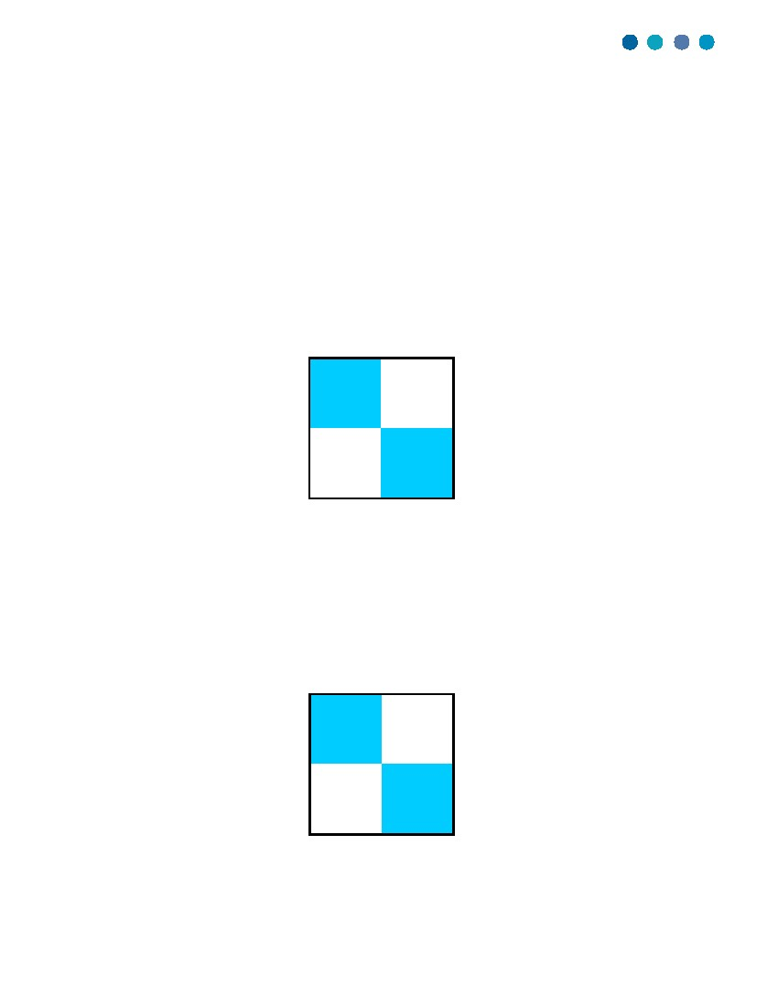
Emphasis is on shaping the environment by
overcoming opposition to accomplish results.
DESCRIPTION
This person’s tendencies include
getting immediate results
causing action
accepting challenges
making quick decisions
questioning the status quo
taking authority
managing trouble
solving problems
Emphasis is on shaping the environment by
influencing or persuading others.
DESCRIPTION
This person’s tendencies include
contacting people
making a favorable impression
being articulate
creating a motivational
environment
generating enthusiasm
entertaining people
viewing people and situations
with optimism
participating in a group
This person desires an
environment that includes
popularity, social recognition
public recognition of ability
freedom of expression
group activities outside of the
job
democratic relationships
freedom from control and detail
opportunities to verbalize
proposals
coaching and counseling
favorable working conditions
ACTION PLAN
This person needs others who
weigh pros and cons
calculate risks
use caution
structure a predictable
environment
research facts
deliberate before deciding
recognize the needs of others
ACTION PLAN
This person needs others who
concentrate on the task
seek facts
speak directly
respect sincerity
develop systematic approaches
prefer to deal with things instead
of people
take a logical approach
demonstrate individual follow-
through
To be more effective, this
person needs
to control time, if D or S is low
to make objective decisions
to use hands-on management
to be more realistic appraising
others
to make priorities and deadlines
to be more firm with others, if D is
low
This person desires an
environment that includes
power and authority
prestige and challenge
opportunities for individual
accomplishments
wide scope of operations
direct answers
opportunities for advancement
freedom from controls and
supervision
many new and varied activities
To be more effective, this person
needs
to receive difficult assignments
to understand that they need
people
to base techniques on practical
experience
to receive an occasional shock
to identify with a group
to verbalize reasons for
conclusions
to be aware of existing
sanctions
to pace self and to relax more
C CONSCIENTIOUSNESS (parent)
Emphasis is on working conscientiously within
existing circumstances to ensure quality and accuracy.
DESCRIPTION
This person’s tendencies include
adhering to key directives and
standards
concentrating on key details
thinking analytically, weighing
pros and cons
being diplomatic with people
using subtle or indirect
approaches to conflict
checking for accuracy
analyzing performance critically
using a systematic approach to
situations or activities
This person desires an
environment that includes
clearly defined performance
expectations
values on quality and accuracy
reserved, business-like
atmosphere
opportunities to demonstrate
expertise
control over those factors that
affect their performance
opportunity to ask “why”
questions
recognition for specific skills
and accomplishments
S STEADINESS (feminine)
Emphasis is on cooperating with others within existing
circumstances to carry out the task.
DESCRIPTION
This person’s tendencies include
performing in a consistent,
predictable manner
demonstrating patience
developing specialized skills
helping others
showing loyalty
being a good listener
handling excited people
creating a stable, harmonious
work environment
ACTION PLAN
This person needs others who
delegate important tasks
make quick decisions
use policies only as guidelines
compromise with the opposition
state unpopular positions
initiate and facilitate
discussions
encourage teamwork
ACTION PLAN
This person needs others who
react quickly to unexpected
change
stretch toward the challenges of
accepted tasks
become involved in more than one
thing
are self-promoting
apply pressure on others
work comfortably in an
unpredictable environment
help prioritize work
are flexible in work procedures
To be more effective, this
person needs
to be conditioned prior to change
to validate self-worth
to know how personal effort
contributes to the group effort
to have colleagues of similar
competence and sincerity
to know task guidelines
to have creativity encouraged
To be more effective, this person
needs
to plan carefully
to know exact job descriptions
and performance objectives
to schedule performance
appraisals
to receive specific feedback on
performance
to respect people’s personal
worth as much as their
accomplishments
to develop tolerance for conflict
This person desires an
environment that includes
maintenance of the status quo
unless given reasons for
change
predictable routines
credit for work accomplished
minimal work infringement on
home life
sincere appreciation
identification with a group
standard operating procedures
minimal conflict

The commonly used table below gives an overview of all four DiSC dimensions. Read the dimension descriptions to understand others who are like and unlike you. For the first time masculine, feminine, parent and child have been added.
D DOMINANCE (masculine)
i INFLUENCE (child)

From here we can now see the four quadrants explained in detail. The dominance quadrant shows traits of power, control, results, challenge, and solving problems. This is obviously the masculine quadrant. Opposite to that would be the feminine quadrant which is the steadiness quadrant. Here the qualities of patience, helping others, a good listener, creating harmony, amiable, patient, harmonious, friendly, accommodating, and modest are most prominent. Opposite of these two quadrants we have conscientious and influence - conscientious being the parental quadrant with influence being the child quadrant. Conscientious people adhere to rules, standards, concentrate, think analytically, check for accuracy, and are systematic in details – clearly the rule bound style of parental behavior. Opposite is the child quadrant which contains personality traits of being social, enthusiasm, entertaining, optimism with people – fun is the key factor here. From these four quadrants we now have a new refreshing new view of how we fit together.
By adding parent/child to the natural popularity of studying differences between men and women we finally have a complete picture. These are the four factors in the human race - the four factors in family. Of course a family can have less than all four factors – it just can’t have more or anything else.
The first question everyone asks is - How do women stay feminine in a D personality and how do men stay masculine in an S personality? Are you mixing and confusing the genders by applying masculine tendencies to women and feminine qualities to men? Everyone has long known that there are happy fulfilled masculine women, feminine men, adults who play as little children, and children who display all these characteristics. It is a personality trait not the determining of sexuality.

D – strong woman, strong man
I – playful man, playful woman
S – gentle man, gentle woman
C – men’s rules, woman’s rules

Some women are strong and powerful while other women are gentle and feminine. Are you going to look at powerfully strong D woman negatively or as the confident women who know what they want and go get it? Or can you view the gentleness of a man who can be strong enough to display charity, forgiveness, and gentleness most of the time? From here we can now for the first time gain further insight into the differences between men and women by relating them to parents and children. From here comes the work of learning and using the ways that people want to be treated.

We now understand how to treat people. It is now time to put it into practice and do it.

As society matures it becomes easier and much more common place to see at least two areas, namely male and female, emerge as complementing opposites. It requires more insight and discipline to recognize all four areas together – male, female, parent, child. How often have people seen the pairing of male and female or the pairing of parent and child and not recognized that all four go together. It is difficult enough just to understand men or women – only half of the full quadrant. The confusing and difficult nature of understanding men and women is the basis of many jokes and humor. How they are similar and at the same time different. It takes practice enough just to learn to think in duality let alone thinking of all four. It is the double duality providing balance one to another. It appears complete while at the same time being simple or at least simple enough.

The Relationship between Masculine/Feminine and Parent/Child Dynamics © December 3, 2010
By Toby Jensen
tobyjensen.blogspot.com
tobyjensen@live.com

