STRESS IS LIKE LIVING IN AN AMBULANCE
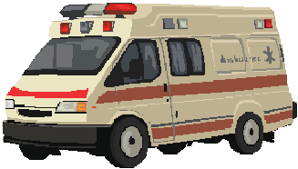Stress is defined as a reaction to a threat, emotional or physical, real or imaginary. Most people in the world are stressed at some stage. Most people in the world feel threatened from time to time.
Stress is a feeling of pressure that produces adrenalin and creates a sense of urgency. Stress is exhausting and limits our ability to respond. There are so many physical symptoms linked to stress that some theories suggest most of humanity's problems are caused by stress. Some of the symptoms are irritability, inability to focus, headaches, increased heart rate, muscle tension, insomnia (inability to sleep), confusion, high blood pressure , frequent illness and various types of pain.
Living in stress is like living in an ambulance all your life. You are on the road most of the day, you live in a small space, not many people around, everything is difficult, your decisions are all about life and death, mistakes are critical, there is no time to waste, not time for fun, not enough time and space to make your own meals, you see (too) many doctors, you develop a dark view of the world from frequent exposure to accidents, drink driving, violence and self neglect. Through the eyes of the stressed person life sucks!
There are many reasons for people to feel stressed. Often, it is the accumulation of more than one source of stress that creates enough pressure to exhaust people.
Historically, body's mechanism to handle a real threat was the “fight or flight” response, which would a massive surge of energy for a short period of time. However, when this mechanism is triggered too often, our body runs out of energy.
Unfortunately, over the years, people started to react strongly to frequent, minor triggers. Something that someone says to us can be a threat, something that does not happen the way we expect can be a threat, but those things build up until our response to them is similar to “fight or flight”.
Even more unfortunately, this trend is only increasing.

What can cause stress?

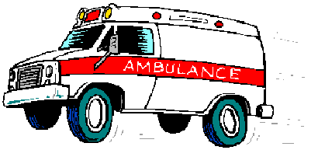Poor diet
Unfortunately, when stressed, people tend to eat things that interfere with the absorption of nutrients. Lack of vitamins and minerals can cause stress, creating a vicious cycle - you are stressed, therefore you do not eat well, but then your body lacks nutrients and you become more stressed…
In this case, it is important in stressful situations to stick to healthy eating. Have an emergency plan for emergency situations and stick to it. If you are stressed, ask yourself “What do I need to eat to give my body enough nutrients for me to relax?”

Change
Most people find it hard to deal with change. Even planned changes like moving to a new job or moving to a new house create a sense of pressure , mainly because of the fear of the unknown. If you think about it, the unknown is there all the time, in every second of our life and in order to survive it, we need to stick to controlling what we can. I can control what I do during the move, I can control my actions and behaviors and I can choose a house to suit my needs.
Unplanned changes, like accidents, death, illness or crisis create stress ever more, because of the sudden loss of certainty.
The only thing constant in life is change
- François de la Rochefoucauld
It is important to understand that we are changing all the time and that change and growth go hand in hand. Preparing well to planned changes will help you deal with unplanned changes. In a strange way, you can also be certain that unplanned changes will occur and when they do, your certainty can increase.

No money
Most of the people in the world live a lifestyle that is hard to maintain. Although education is perceived to be free in many countries, children actually cost their parents lots of money. In many places around the world, people do not have enough money for food (have you seen the movie "Slumdog Millionaire"?). If you ask people about the causes of stress (called “stressors”), you will find that lack of money is at the top of the list, causing them many sleepless nights.
Stress regarding money increases during crisis, so the best way to avoid it is to manage your money wisely. Live within your means and always put some extra money for a rainy day.

No time
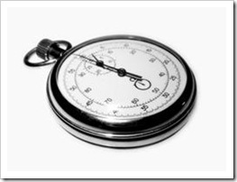Lack of time is a growing source of stress in our society. Most people work many hours, long days and do not have time to do all the things they want or have to do. Others are just “time wasters” and are not efficient in their time management. Yet, we all have 24 hours a day and we can manage our time, rather than letting our time manage us. Here are some symptoms of time wasters:
- Being disorganized
- Not knowing how to say “no”
- Planning to do too much for the time allocated
- Not taking time to rejuvenate
- Watching too much TV (this includes YouTube, idle Net surfing and playing video games)
- Inability to delegate properly
- Procrastinating
- Not having good systems
- Having too much clutter and a messy home/desk/shed/office
- Avoiding helpful technology
- Being easily distracted and allowing interruptions
The way to solve the time management issue is to build your time management skills and understand that the difference between being stressed and relaxed is the way you manage your time. Develop techniques and ways to handle your time when you are relaxed. It will help you greatly when you are not.

Relationships
Many people feel pressured regarding their relationships with their boss, partners, friends, parents, in laws, kids, employees, clients, etc. Most of the time, the pressure builds when there is a verbal or non-verbal expectation to behave differently.
The solution to pressure from others is confidence! Personal development is a way of building confidence. You learn about yourself, your desires, your mind and your attitude and you learn to design your life to your advantage.

Inability to switch off
Many people, when feeling stressed, are unable to switch off from working, thinking, taking care of others or any other thing that occupies all of their being. Many times, this can cause insomnia and inability to relax. It is like riding in an ambulance with the siren on all the time. Remember, even an ambulance needs to stop to refuel and recharge. This inability to switch off does not allow people to enjoy coming home from a full day at work or enjoy a holiday they have worked hard to pay for.
Find out how many hours of sleep you need and stick to them. During stressful times, sleep even more, because stress is exhausting. Do not bring work home (if you have to, do it only after your kids are in bed). On holidays, turn your mobile phone (and every other beeping and vibrating device your own) off and avoid checking your emails. During a work day, stop every hour for a stretch, go to the toilet, talk to someone and drink some water. This will help you recharge and function better.

Indecision
Just like the urgency in making decisions in an ambulance, some people find it hard to make decisions. Deciding what house to buy and what dinner to cook can create the same feeling of stress sometimes. In a way, not making a decision is a decision in itself and people fall into the trap of waiting for divine intervention or circumstances that to make the choice for them, but this only increases their insecurity and makes it harder for them to make new decisions.
The way to handle this challenge is to remember that we are not fortune tellers and at any given time, we do the best we can. Also, we are rarely faced with life or death situations. Spaghetti or rice? Who cares? Bring it on!

Lack of significance
Some people are so insecure they depend on others to feel appreciated and happy. The need for others to fill their significance tank creates lots of stress, disappointment and later anger. Those people usually feel unheard, unappreciated and spend a lot of effort pleasing others to gain some acknowledgment, but this is a vicious cycle, because it increases the feeling of dependency and requires more appreciation from others later on.
The way to handle such stress is to learn self appreciation, self love and develop self confidence. There is always something good you can find in yourself - your smile, your manners, your sense of humor, some achievement at work, a good intention, a kind deed. Seek and ye shall find.

Use of drugs
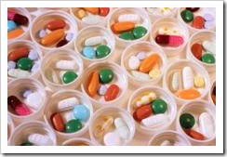Use of drugs comes with some physical comfort, followed by some form of panic when the drug wears off. The dependency creates lots of pressure , the need for money creates pressure and sometimes the need to hide the use creates a lot of pressure .
The only solution for this is not to use drugs!

Too much alcohol
Alcohol may be legal, but it is still a kind of drug. In the US alone, about 14 million people have been diagnosed with disorders associated with alcohol (not the occasional social drink or wine with dinner, real heavy stuff). Again, the dependency, the money required and the social shame are huge stressors. By the way, alcohol stress is a matter of life and death, because more than 100,000 deaths each year in the US are caused by excessive alcohol.
The solution is not to drink!

Narrow mindedness
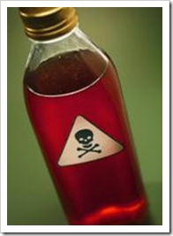Narrow minded people cannot see options in difficult situations. They feel disappointed and frustrated with many conflicts and crises in their life, but do not see any way out of them. This inability to see options and solutions creates lots of stress and a feeling of helplessness.
The way to overcome this problem is to look at situations from different points of view - big picture, more detailed, future perspective or “What would I do if this were a similar situation in a different setting?” Ask yourself “What are my options?”, “What is the worst thing that can happen if I do <each option>?” and “In two years, what will I think about this situation?”

Negativity
Negativity can cause a lot of stress. Negative people see a black future, they find faults in many things, they lack hope and motivation and this drains them of their energy. Being a negative person is like living in an ambulance while only hearing constant pain and expecting that the next patient will die and the next one and the next one … every time, all the time. Negative people forget that the ambulance is all about saving lives.
To change from a negative to a positive mindset requires the ability to see good, do good and respond in a good way to things. Focusing on a positive outcome, visualizing a good future and having positive affirmations can greatly reduce stress. The funny thing is that good exists everywhere and it only takes a decision to start seeing it.

Difficulty to self express
One of the biggest stress-causing challenges is people's difficulty to express their feelings and their thoughts. When people bottle up, this creates pressure that may one day blow up, more often than not out of proportion.
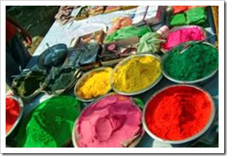The solution is always to find someone to talk to. It can be a friend you trust or a professional. Alternatively, you can find a creative way to express yourself. Art provides wonderful ways of self expression. It is a good idea to have such an outlet long before the tension becomes too heavy to bear. In stressful situations, find a way to rearrange your thoughts and sort out your emotions.
Everyone, without any exceptions, experiences stress in life. Being unpredictable and exciting, life contains many stressors. Instead of letting stress control you, take the responsibility of opening the door and getting out of your ambulance. There is a beautiful, safe world out there.
Happy relaxed life,


