POSITIVE FOCUS
Life is a fascinating journey into the self. On your back, you can carry flowers or pink elephants ... dancing ... wearing a tutu
– Ronit Baras
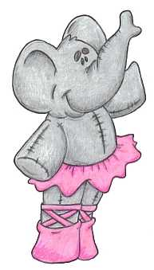Most of our coaching clients ask us, “How come I keep getting all the things I don’t want to have in my life?” Oddly enough, the answer is hidden in the question. It is all to do with … pink elephants.
Our brain is a very sophisticated machine, with its own way of interpreting the things around us. It turns out that one particular thing our brain cannot understand is negatives. Whenever we hear or use the words “no”, “not” or “don’t”, the brain simply ignores them and keeps the rest.
Let me demonstrate:
Please close your eyes and do not think of a pink elephant … dancing … wearing a tutu. What happened? Could you not think of it? If you are like everyone I know, you saw that very elephant you were supposed not to think about, even if for a brief moment. There is no other way. We need to bring the elephant into out mind before we push it out.
And that is exactly how our brain deals with all the negative expressions in our life. When we focus on what we do not want, we actually bring that very thing and into being and then fight it.
“I don’t want to feel like that” translates into “I want to feel like that”.
“Don’t talk back to me” translates to “Talk back to me”.
One of my clients, a 37-year-old gorgeous-looking woman, who looked like a 20-year-old, was in search of a partner. “I don’t want those 25-year-old kids to look at me”, she said and, sure enough, all the men she attracted were around the age of 25. Frustrated, she asked, “Do I walk with a sign over my head saying ‘If you are 25, talk to me?’”. What do you think? If you understand pink elephants, you know she did. The things we do not want in life are also the things we mostly focus on and by doing this, we bring them into our life, instead of avoiding them.

Parents often describe their children as doing exactly the opposite to what they tell them. Actually, they can’t help it. For example, when a parent says, “Don’t run in the house”, the child hears, “Run in the house”. Can we blame the child for running? Could you not think of a pink elephant?
Let us consider some other things you will surely find familiar. What do you think your brain remembers every time you pass the highway sign that says, “Don’t drink and drive” or “Don’t speed”?
Think about it – “No smoking” is the best advertisement for smoking. It brings smoking to our attention, and keeps reinforcing it, because it is everywhere.
What do you think of a nation using the expression “no worries” in response to almost everything? Are they really not worried at all?
A major modern “pink elephant” is the expression “fat free”. How do you explain the increase in the world’s obese population when everybody keeps promoting so many diets and “fat free” products? We focus on fat and then we fight it. People, who sell “weight loss” products, are actually promoting … weight. If you made so much money selling weight-loss products, would not you do that too?
Negative attitudes towards work, relationships, business, housekeeping, family, friends or enemies can be changed by changing focus.

Start by asking yourself, “What do I want?” As with any journey, we must first identify the place we are going to. This gives us direction and guides our daily focus and action.
Once our aim is set, the most magical thing happens – all of a sudden, we start noticing things we have never spotted before.
One of our clients wanted to have some time to himself in the busy life he was leading. “I just need 6 hours for myself”, he said. He took it on himself to record his time on an hourly basis for a week. To his amazement, he discovered he was already spending 16 (!) hours every week in personal activities.
Another client wanted to feel loved and appreciated by his wife, claiming she always wanted him to do things for her and then took his efforts for granted. He decided he would spend a whole week collecting evidence of his wife’s approval and affection. Do you think he found some? You bet he did, and lots of it!
By focusing on what you do not want, you summon “pink elephants” into your thoughts and you are in constant battle with life. And life, after all, is a fascinating journey into the self. On your back, you can carry flowers or pink elephants … dancing … wearing a tutu.
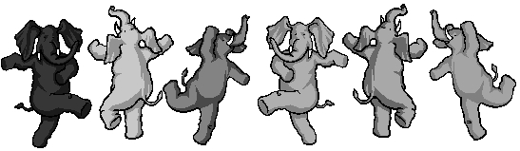
May the force be with us!
Ronit

