Being trustworthy won’t make you a Trusted Adviser!
Why don’t they trust you enough?
Ian Mills, Chief Executive of Transform People International examines the way customers buy professional services and high value products and the importance that they place on relationships. Is the quality of your relationship the real answer to earning more profitable long term revenue from every customer?
Trust. It’s a key issue in every relationship and it’s the pillar of every business relationship. But what does it really mean and how can you increase the value of every business relationship by better managing the Trust Quotient you’ve established with every customer? Trust will mean different things to different customers. For example, at a personal level some customers may make value judgements about the way you dress, your accent and even your culture. To other customers, none of this matters because they place the value of the relationship on skills, service and delivery.
Crucial concerns
However, there are common themes that research tells us are crucial to all customers, including:
- Dependability– the way you deliver against the promises you make.
- Integrity–how you operate to a consistent framework of principles such as honesty.
- Credibility–the ways in which you display your knowledge and expertise.
- Empathy – how you show that you intimately understand your customers business, their challenges and their priorities.
- Customer Centricity – the adoptive focus of your solutions against the issues your customer faces ... taking the “you” and not “we” approach.
- Consistency – ensuring that your customer experiences the same quality of service, regardless with whom they engage, whenever they engage with your organisation and whatever commercial challenges they face.
Think about this. You’ve had an enjoyable relationship with your customer, probably for a number of months, possibly even years. The trouble is that the customer has never really spent as much with you as you know they could and as you think they perhaps should. Something tells you that, for whatever reason, you have not acquired as big a share of the customer’s wallet as you’d like. The customer seems to “trust you”, but does not appear to see you as a ‘Trusted Adviser’. They reserve that status for their accountant, or their lawyer, their best friend from business school ... or, dare I say, even their spouse, or partner. But why?
Who are you?
You now face two choices: you can give up and move on, or you can wrestle with the problem and take back winning control of the situation. It then becomes a question of who you are. Are you a sticker, or a quitter? Most decision-making customers would confirm that a key characteristic of a Trusted Adviser is their relentless pursuit of value add solutions where there is a win:win outcome to wrestle with and negotiate.
If you want a bigger share of customer’s wallet, there are two routes you can adopt.
Route 1 means bombarding them with services, products, help and assistance. You can hit them with lots of backup and support and offer every other trick the universal sales manual teaches you. But to be brutally honest, it won’t make a whole lot of difference what you do. You may find that they buy more and more frequently because you strike lucky once or twice with a premium price product. Your share of their wallet will significantly improve, but only in the short term. Without a better quality relationship this customer will always be “at risk”. When a better product becomes available from another source this customer will transfer their allegiance to your competition.
You may have demonstrated to the customer that they can trust you, but you have not yet gone beyond the status of a ‘trusted transactional vendor’. You have not shown the customer that what you have to offer is centred on their needs – it’s been more about your short term need to sell more, quickly.
Earning ”Trusted Adviser” status
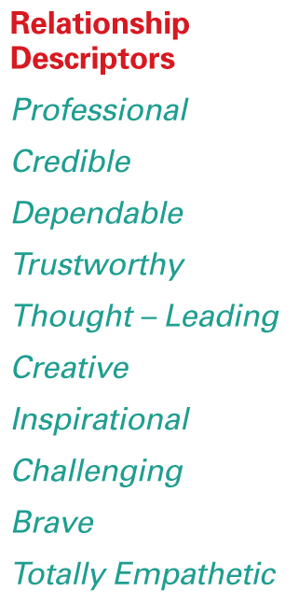
Route 2 is to take a look at the Trusted Adviser Grid (see below) and be ruthlessly honest with yourself. Think about where you would plot your customers on the grid and follow these simple steps:
- Read the 10 relationship descriptors such as dependable, brave, trustworthy.
- Consider how many of these descriptors your customer would use if we asked them to describe your relationship.
- The number that apply will determine where the customer is on the horizontal axis eg: if three out of the ten apply then the customer will be 30% along the line from the left and so on.
In terms of the vertical axis:
- Consider not only what the customer is currently buying from you and your competitors, but also what you feel they should be buying if they really understood the value you are offering.
- Based on whatever measure you choose (revenue, contribution, number of products...) determines how far up the axis the customer should be placed in the same way as before 30%, 50% and so on.
- Join the dots with the other axis and the position will determine the start point for planning your engagement strategy.

Trusted Adviiser Grid™ - Possible Strategies
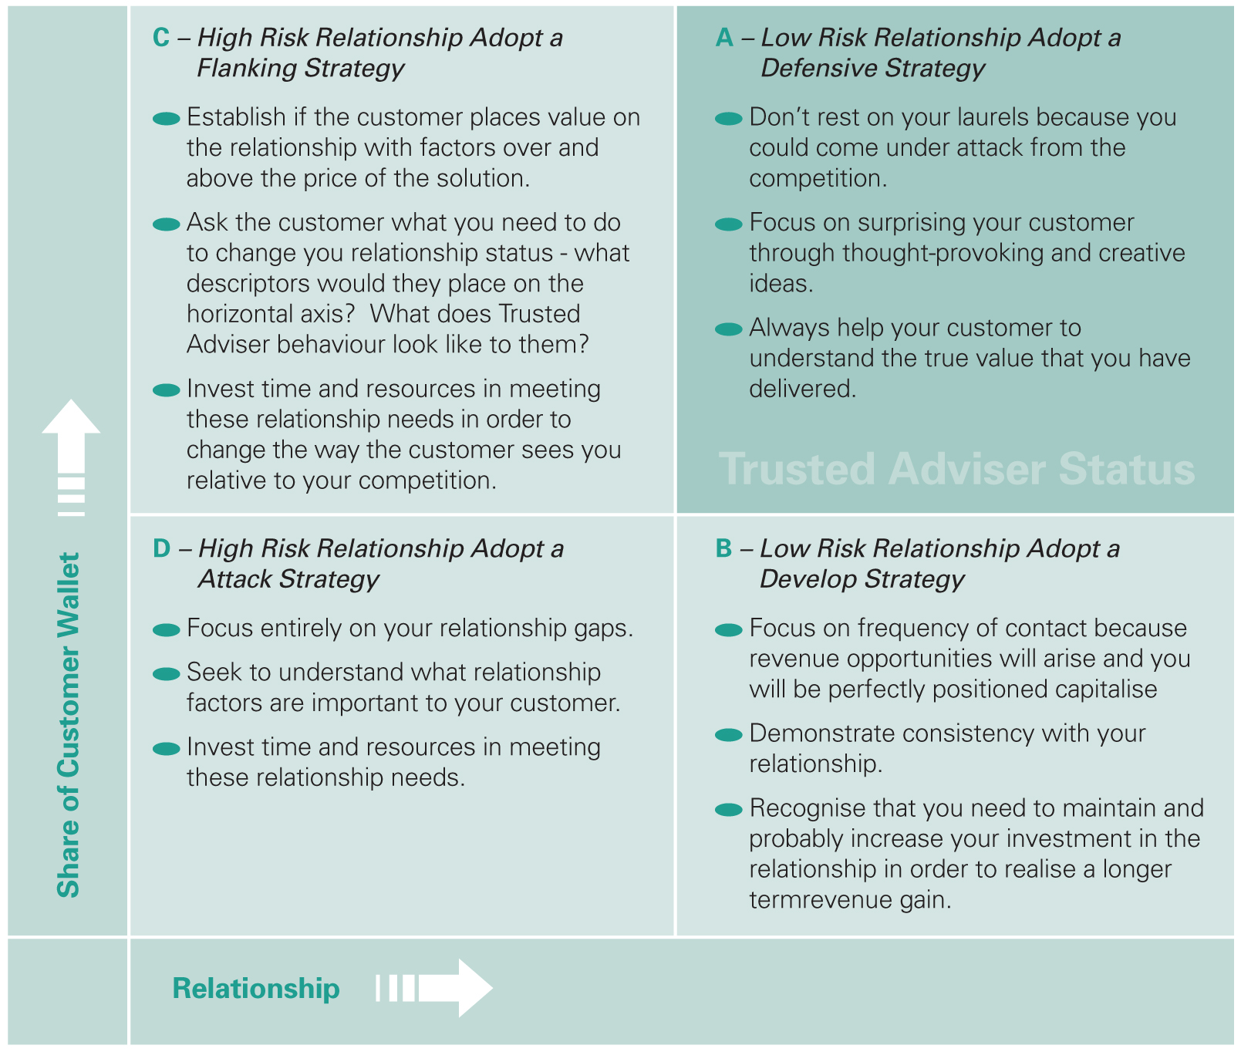
Examples
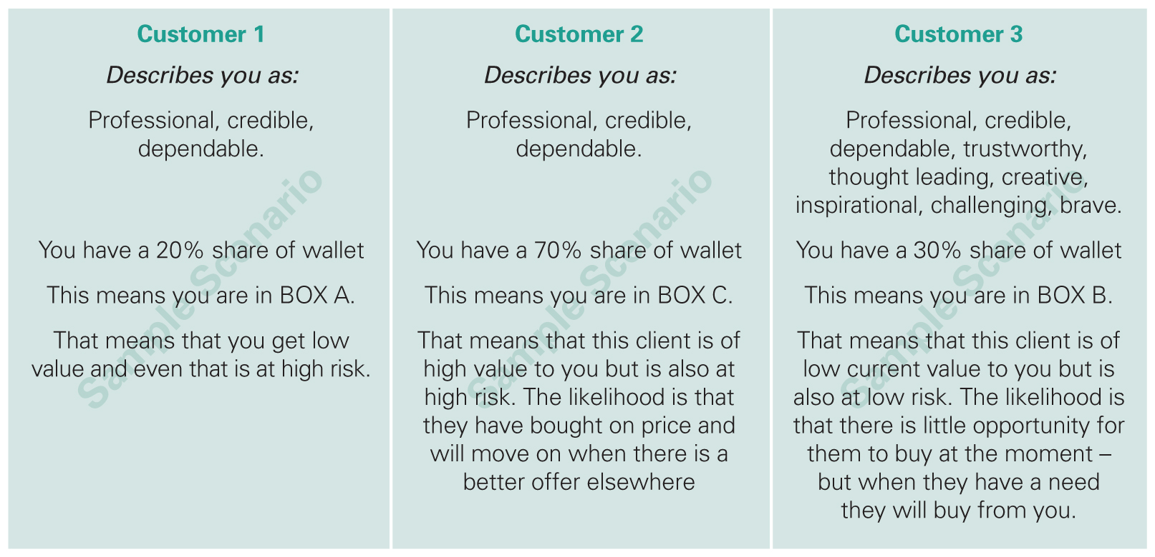
Intuitive and inspirational
The Trusted Adviser Grid is a remarkably intuitive and inspirational device. In simple terms, it tells you where you stand and indicates what you have to do to drive every customer relationship towards Trusted Adviser status. And you can apply it easily to any industry or market sector.
But of course the sheer simplicity of the Trusted Adviser Grid also masks its working complexity. How do you make the changes that are necessary by person, by team, by region, department and division to make all of your business relationships bear even better and bigger fruit? How do you get your people on the right road to success?
What does this mean for you?
Decision-making executives will invest more time, will buy more, will provide references to new opportunities that validate their own buying decisions, will help shorten the time it takes to close business by cutting through complex processes ... with their Trusted Advisers. In short, a Trusted Adviser will generate long term and profitable revenue by focusing on customer-centric behaviours and will not simply concentrate on the amount of revenue they have delivered this week or quarter.
The challenges that all business professionals should be rising to are to re-examine their day to day behaviours, ensure that they are not adopting a one size fits all approach to customer relationships and proactively understand what kind of relationship their customers actually want. Only then can they really say that they are on the road to Trusted Adviser status.

At Transform People International, we have been working with companies for over ten years to make precisely those kinds of changes in people, teams, structures and organisations for companies all over the world. Our transformational successes for customer companies such as Cisco, Coca-Cola, LloydsTSB, Morgan Stanley and Reuters speak for themselves and silently speak volumes for our company. We know what it takes to make the changes that matter for you and your people. We also know how to do it successfully, discretely and with sustained effect. And so far we’ve done it for customer companies in 40 countries across every continent.
Details of our approach to business and the company’s culture can be found at www.transformpeople.com. Contact email: ian.mills@transformpeople.com Telephone: + 44 (0) 1488 658686.

© Transform People International 2008

