Getting a “GRIP” on your teams – how to get better results from the same people

What better results from your teams? John Fillingham, independent trainer and consultant describes the often painful process of “managing” people and what it you need in place to increase your chances of success in getting better results and feeling less stressed.

Who wants to be a manager and motivational buttons
Who put up their hand in class when the teach asked the question “what do you want to do when you grow up?” and replied gleefully “I want to be a manager!” not many I’m guessing. Me - I’d rapidly run a hundred miles up a long hill just at the thought of looking after those unruly, fragile, demanding, doing their “own thing” crazy bunch of people. When someone first generously gave me a team (yeah thanks and isn’t my job difficult enough already?) I thought - I can do this, just gently push a few of the motivational buttons and everything will workout fine. Well, looking back I was pretty terrible, a real amateur who repeatedly made truly basic errors, but you eventually move on from them, learning along the way and with a little help, hopefully getting better, or in some cases (naming no names), you don’t!

People, theories and the absolutes of getting it right
This strange concept of management or “managing people” and sometimes I rub my genie lamp and wish someone would come up with a more reflective title, one that really indicates what the job is really all about – PEOPLE, people, people. The job often comes with pain, worry and endless stories of difficult employees and whining team members all bringing their personal problems to you – but it doesn’t have to be like that…so what is out there to help you? What can quickly reduce your pain and bring down your blood pressure? When I first began as a novice manager I had a pretty good idea of what the theories said and I had already seen plenty of bad examples of how NOT to treat people, but how to make it really make it work and rock your team, I soon realised I didn’t have a clue. It took me years of fumbling around in the dark to really find an effective style and checklist of absolutes I knew that I should never drop off the to-do list to “manage” my teams. I’m going to share some of these strategies with you today. I look back now and ask-where was the help in all this time? I aspired to great things, in fact to me, I was already the best boss around, but did they think the same and would they even tell me if they didn’t? I hoped somehow they would say nice things and give me the benefit of the doubt for being a nice person.

Buckets of theories, Buckets of frogs, secret ingredients
Do a quick search on the internet in any book website, you’ll get a shock as to how many shiny new books there are on management topics. Awash with woefully diverse theories and with so many models of what competencies you should have, what core skills, what important personality traits, what impressive clothes you should wear…everything in the search to describe how to be the perfect “manager” “leader” / “person”. Some as complex and difficult to handle as a bucket of frogs so for me, (Keep It Simple Stupid) to be able to get my head around it, so I could easily explain it to someone else, I need simple, down to earth stuff that’s not too big, I have a busy schedule remember and my fragile attention span won’t last long either, so I need things that I can be sure of will work most of the time. Well hold onto you hat’s folks, let me let you into a little secret that makes everything work properly, keeps everything on track, the one word that sums it up is… “structure”, or systems, depending on how you want to phrase it, bottom line – same principle. Hey, you say, haven’t we got too much of that already, isn’t that what everyone is complaining about?

Chaos, purpose and the domino effect
Too much of anything of course is bureaucratic suicide but without the right structural elements, particularly when it comes to managing people, everything can easily become unequivocal chaos. I should know, that’s how my time management used to be! If you take more than a fleeting glimpse at the world around us, you begin to realise that structure saturates our daily life and every moment of our existence. Everything and I really do mean everything, has a definite and clearly defined purpose (if you look hard enough, believe me you’ll find it). Every event, like a set of dominoes, triggers another and another and another in a constant sequence of dynamic events, interactions and experiences, good, bad and sometimes a little crazy.

Tribal groups, isolation and the emotional glue of relationships
So if structure really does pervade every aspect of our existence (and if you talk to any scientist they can bore you senseless with the structure of everything from plant life to how the world began) – how come then it seems to become so difficult to apply when we step into an organisation? Is the modern work environment so far away from our natural evolutionary tribal state that it becomes a false and artificial drama of conflicting and endless battles? Well, whatever your view, we can be generally considered as pack animals and therefore to exist in total isolation maybe not the way to go, some try of course. However, you can draw the logical conclusion that the natural state is to function in groups and teams, in a set of linked up relationships that support and encourage personal growth held together by the emotional glue of personal interactions.

So the question quickly become, how we do create such a structured, well ordered environment to ensure our beloved teams get what they need to be able to grow, flourish and competently deliver what is expected, to see the great results of our best efforts at team management perhaps you need to get a GRIP….

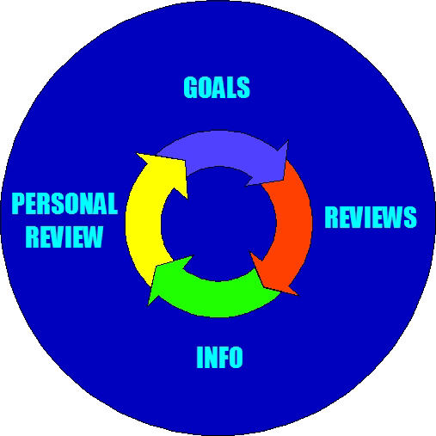

Getting a GRIP of your results and your team
STAGE 1: Goals – set focused targets AND crystal clear standards, the thing you want them to aim for (the WHAT), then the standards of HOW to achieve it, by defining the acceptable the unacceptable and the excellent standard of doing it. Clearly explain the purpose.

STAGE 2: Reviews – regular reviews, e.g. on a monthly or weekly basis, whatever fits. This keeps track of progress and together you can solve problems with coaching or guidance. This helps stop disastrous results and poor performance.

STAGE 3: Information – give it, keep people informed, generate feedback on how they are doing on a daily or at least regular basis and discuss what else is going on in the bigger picture. This is in addition to the reviews.

STAGE 4: Personal review – carry out an annual review, a positive, a development discussion for growth or stretch and a place to agree new targets. With NO surprises this should be the most motivating discussion of the year.

This cycle should be continuous. However, each component must be delivered correctly. Less tell, rather more asking their opinion on it before you launch in with an answer is far more motivating.

The proof of the pudding is in the eating, less stress, less headaches
Having grappled with a number of different sized teams over the years, I can tell you, this stuff really works. You have to make time to do it, there’s no getting out of that, however, when you do, you begin to realise how powerful it is and over time, how easier your life becomes, less headaches, less stress, less problems. So if you want a better night’s sleep, people in your team to do things right, first time round, stop fantasising about doing bad deeds to the people who work for you….get a GRIP!

